Jack McCoy

CS Ethics

Week 10 Homework

Gerrymandering Lilliputia

**YOUR MISSION:**

Experiment with different possible distributions of 0 and 1 voters in Lilliputia

 -- first by playing with this sheet, then programmatically with your python code --

       to find as many examples as possible of each...

0) a situation where 1/3 of the voters are 1's, but a random districting plan is more likely to give them no districts than two districts.

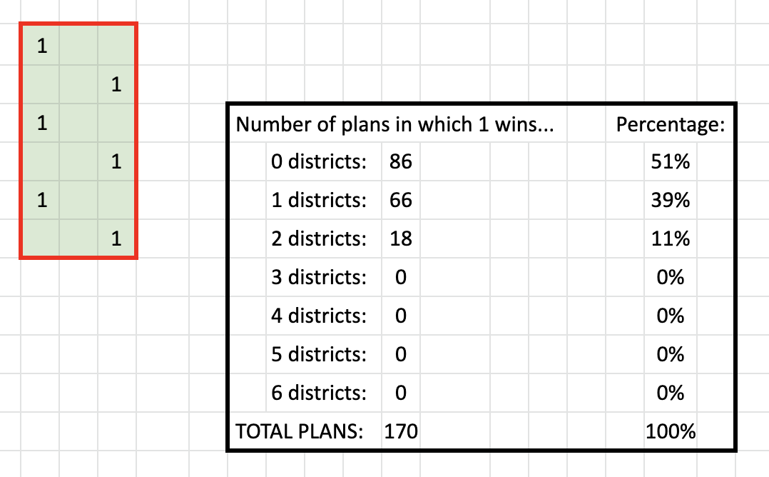

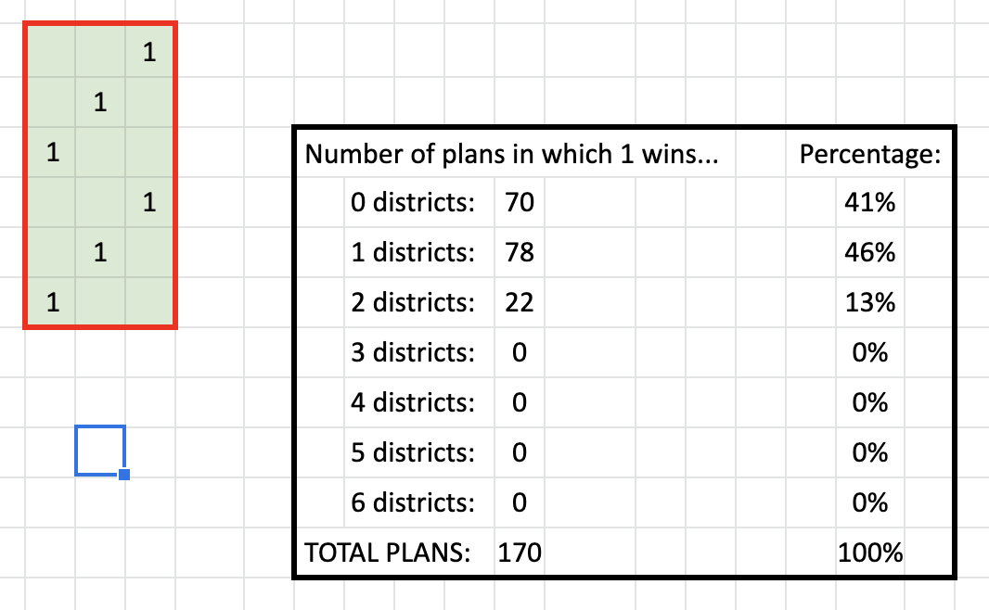

      (Two out of six is what they would get if you had proportional representation.)

1) a situation where 1/3 of the voters are 1's, but where they win no districts (sus)

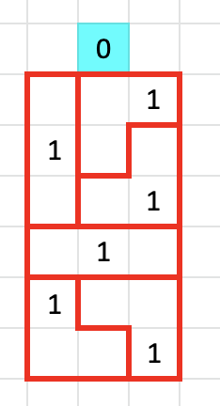

2) a situation where 1/3 of the voters are 1's, and they win 3 districts  (again, sus)

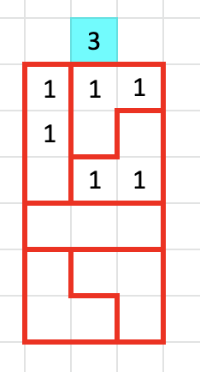

3) a situation where 1/3 of the voters are 1's, but there is simply no way for them to win more than one district (sus much?)

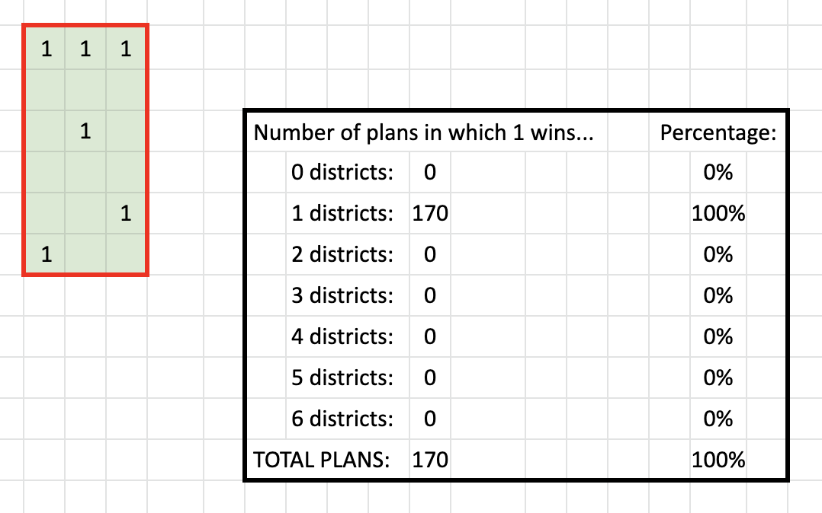

4) situations where half the voters are 1's. More open-ended exploration is in order...

Which arrangements of their voters are most advantageous for Party 1?

Arrangements that pack zeros into areas in which their votes are dilluted

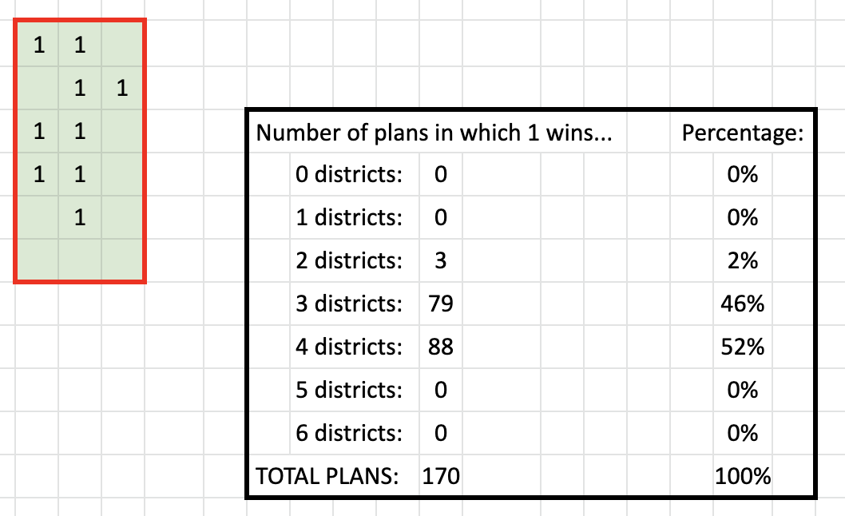

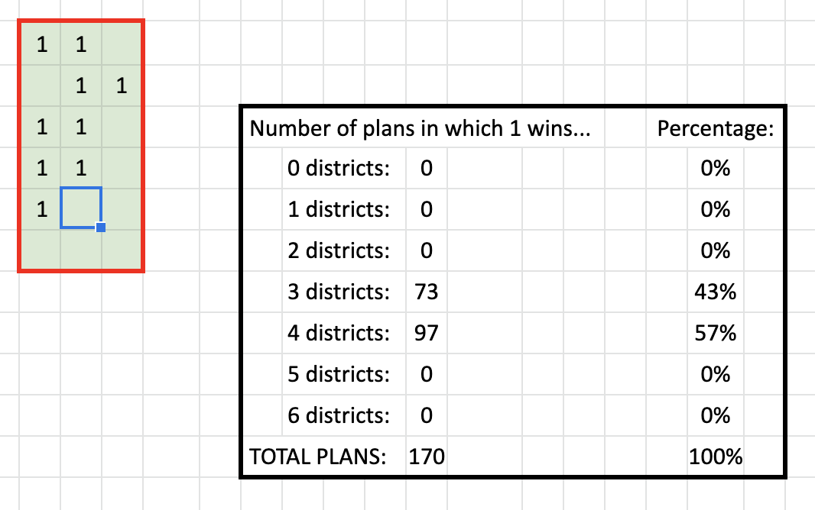

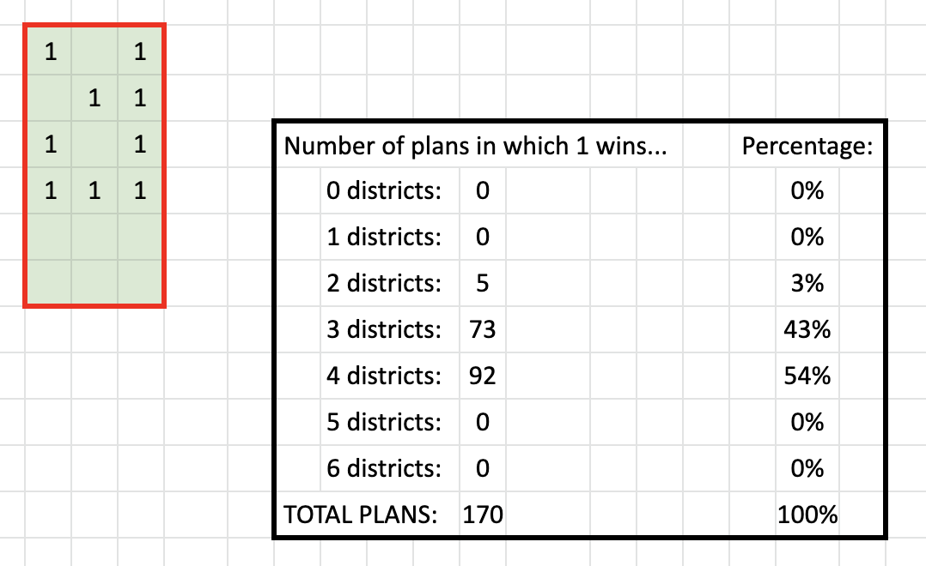

Which are least advantageous?

Arrangements that pack ones into areas in which their votes are diluted

Are there arrangements that are hard to gerrymander in either direction?

When the distribution of zeros and ones are distributed without many adjacent cells containing the same numbers (like a chess board).

